Software Requirements Specification
for
Flex Advisor
Version 1.0
Prepared by Max Garces & Juan Cruz
Capstone 2020
04/20/2020
Table of Contents
Table of Contents ii
Revision History ii
1. Introduction 1
1.1 Purpose 1
1.2 Document Conventions 1
1.3 Intended Audience and Reading Suggestions 1
1.4 Product Scope 1
2. Overall Description 1
2.1 Product Perspective 1
2.2 Product Functions 2
2.3 User Classes and Characteristics 2
2.4 Operating Environment 2
2.5 Design and Implementation Constraints 2
2.6 User Documentation 2
2.7 Assumptions and Dependencies 2
3. External Interface Requirements 3
3.1 User Interfaces Overview 3
3.2 Hardware Interfaces 26
3.3 Software Interfaces 26
4. System Features/Modules 26
4.1 Login Screen 26
4.2 Forgot Password 26
4.3 New User 27
4.4 Register Your Academic Institution 27
4.5 Dashboard 27
4.6 User List 28
4.7 Create User 29
4.8 Paragraph option Menu/Alignment 29
4.9 School Details 30
4.10 Program list 30
4.11 Create IEP 31
4.12 Messaging 31
4.13 View IEP 32
5. Requirements 32
5.1 Performance Requirements 32
5.2 Safety Requirements 32
5.3 Security Requirements 32
5.4 Software Quality Attributes 33
Appendix A: Glossary 33

Revision History
Name | Date | Reason for Changes | Version
Max Garces | 04/20/20 | Requirements and Specifications for version initial. | 1.0
Juan Cruz | 4/23/20 | Clean up and clarification of the text | 1.1

Introduction

Purpose
This document will describe Software specifications for the version 1.0. of a dynamic web-based application intended to streamline the graduation plan process. It will attempt to explain the functionality of the program and the features it offers.

Document Conventions
Each title in this document has bold text, and 12 times new roman for all the specifications and description of the program and requirements. There is no other special font.

Intended Audience and Reading Suggestions
This document is intended to be reviewed by the manager of the tech firm before it is presented to the customer. The costumer will read the document and will check accuracy, clarity and completeness of the requirements and design specifications. Also, the team that will design and implement the system can review project’s capabilities. Moreover, project testers that could use this document as a base for their testing strategy as some bugs are easier to find since using this requirements document testing is more organized.

Product Scope
This web base application uses dynamic web components tied to a NoSQL database to store and display the appropriate functionality for the correct users. With this program, depending on the user type, the user dashboard will be populated, and the sidebar will also allow the user to perform the corresponding actions for the type of user logged in.

Overall Description

Product Perspective
This program is a web-based application that allows users to log into their profile that is associated to a certain academic institution. A system administrator can apply to register their institution directly from the application. The application will be hosted on a static website.

Product Functions
The program will have some core features that are shared throughout.
- Register Institution:
  - A school can be registered through the app
- User Creation:
  - System admin and Program Directors both have access to create profiles for faculty within the same institution)
- Student Registration:
  - Students can register for FlexAdvisor using the school’s academic ID
- Forgot Password:
  - This allows users to reset their password using the provided email.
- Dashboard:
  - Users have access to customized dashboard with important information relevant to their use case.
- User List:
  - Faculty will be able to view user list depending on permission granted by log in

User Classes and Characteristics
The primary use case for this web application is academic institutions. The actual users of the program would be the faculty, and students that are trying to facilitate the advisement and graduation plan process.

Operating Environment
This program will be hosted online using the cloud service Heroku.

Design and Implementation Constraints
This program uses a stand-alone log in system, which could later be tied into a school’s existing system to create schedules and tie the IEP and scheduling process into a single platform.

User Documentation
An email will be sent to the System Admin of the school once the registration for an institution is approved. This will include the System Admin profile for that school, as well and the Academic ID for that school which can be shared with students and a guide on how to set up users to start using the application.

Assumptions and Dependencies
The web application would need all external libraries and node.js packages to be deployed on the Heroku server. Other than server-side dependencies, there are no other outlying dependencies.

External Interface Requirements

User Interfaces Overview
When a user accesses the web application, they will be greeted by the main screen.

Login:
If they are an existing user, they can go ahead and log in. If a user has forgotten their password, they can select the “Forgot password”.
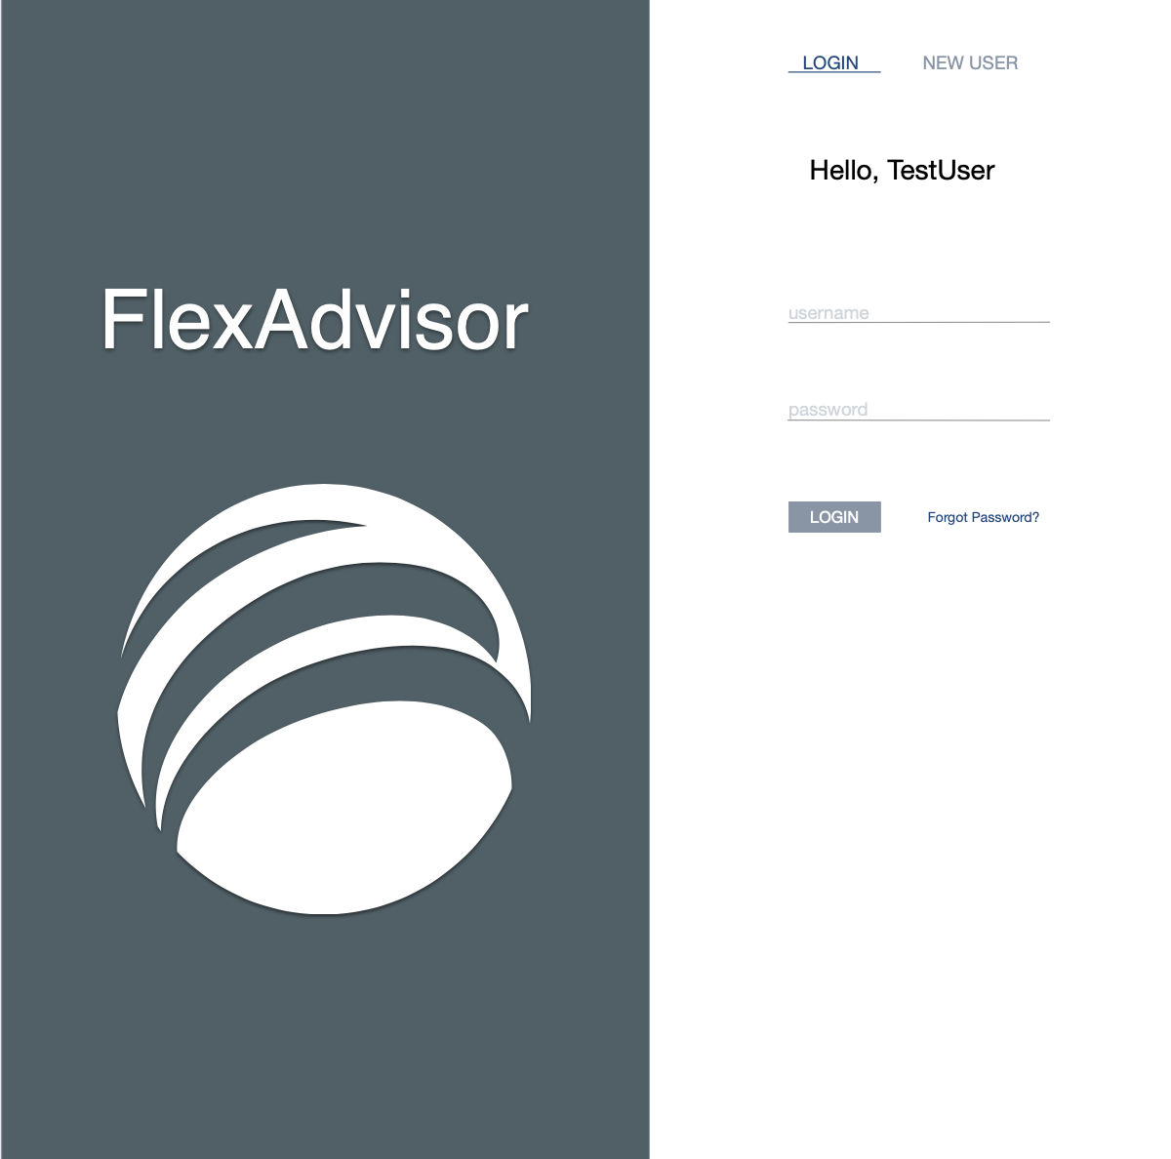

Forgot Password:
Once Forgot Password is selected, the UI refreshes within the same tab and gives the user an option to insert their email and send the email or go back to the main login page.
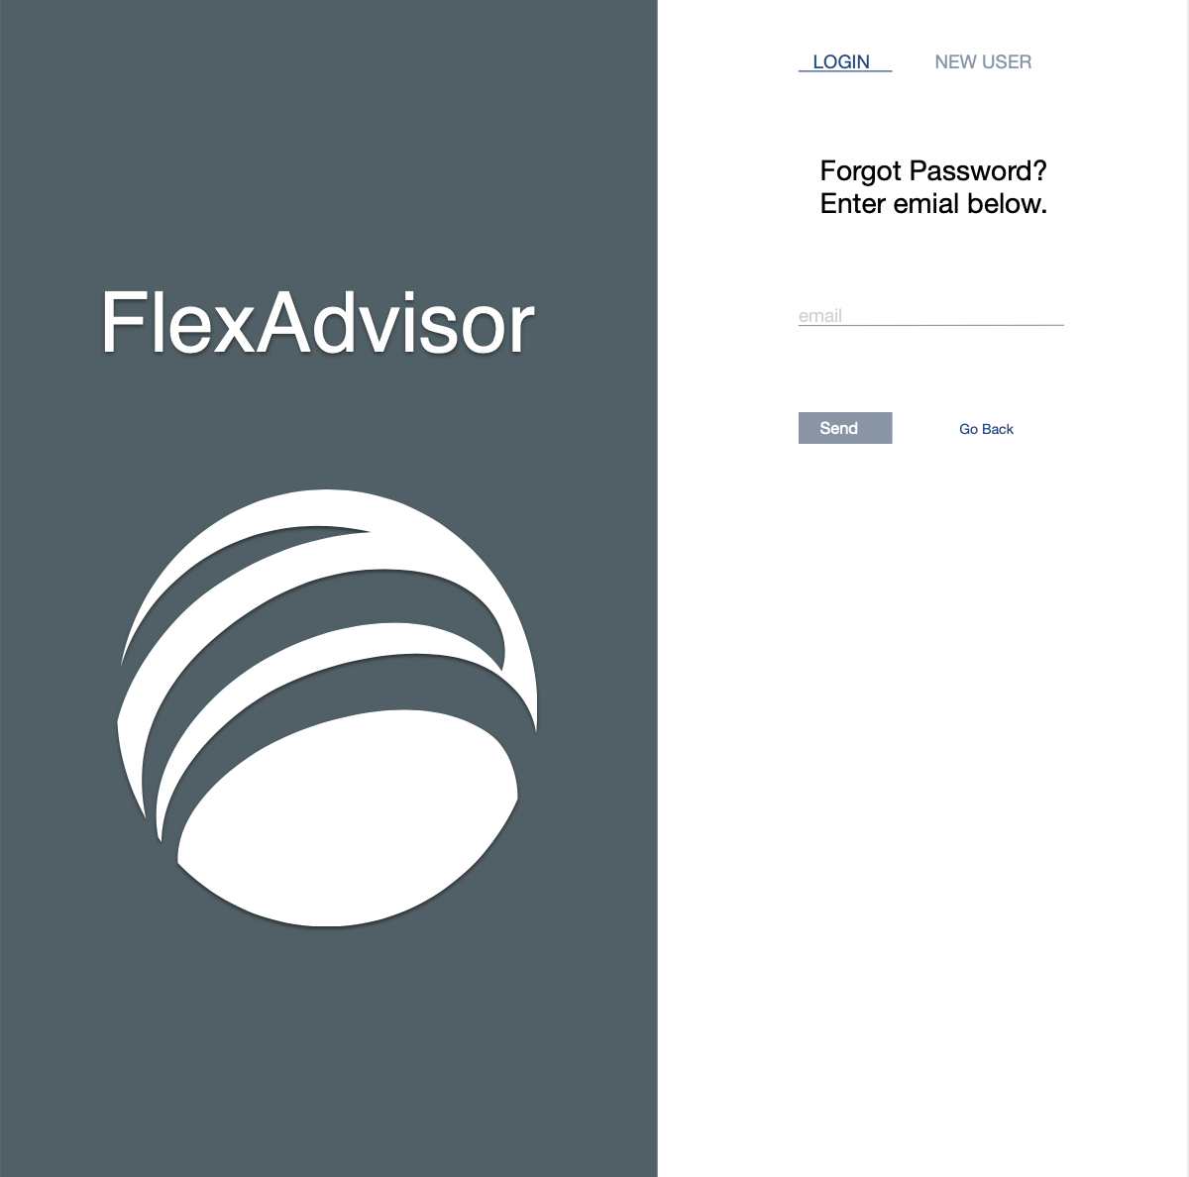

New User Tab:
If they are student looking to create an account, in the “new user” tab they will have to provide the academic ID that is provided to the System admin upon institution registration.
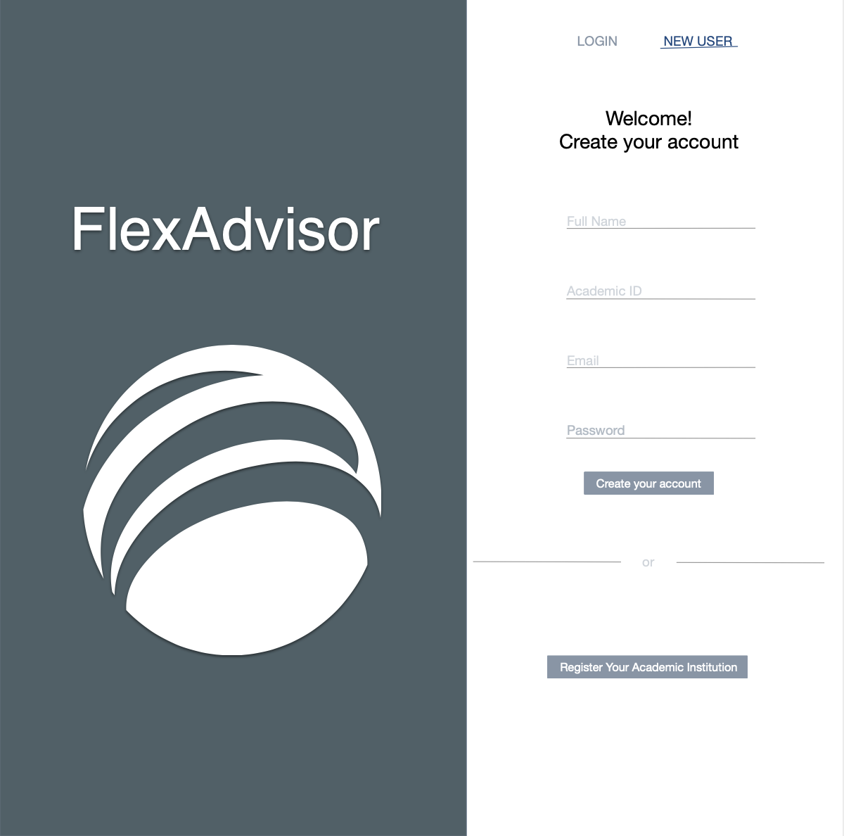

Student Account Creation Screen:
Once a student has entered the creation parameters, they will fill out their preferences (this is the information that is used to dynamically create and send the IEP to the advisor upon account creation).
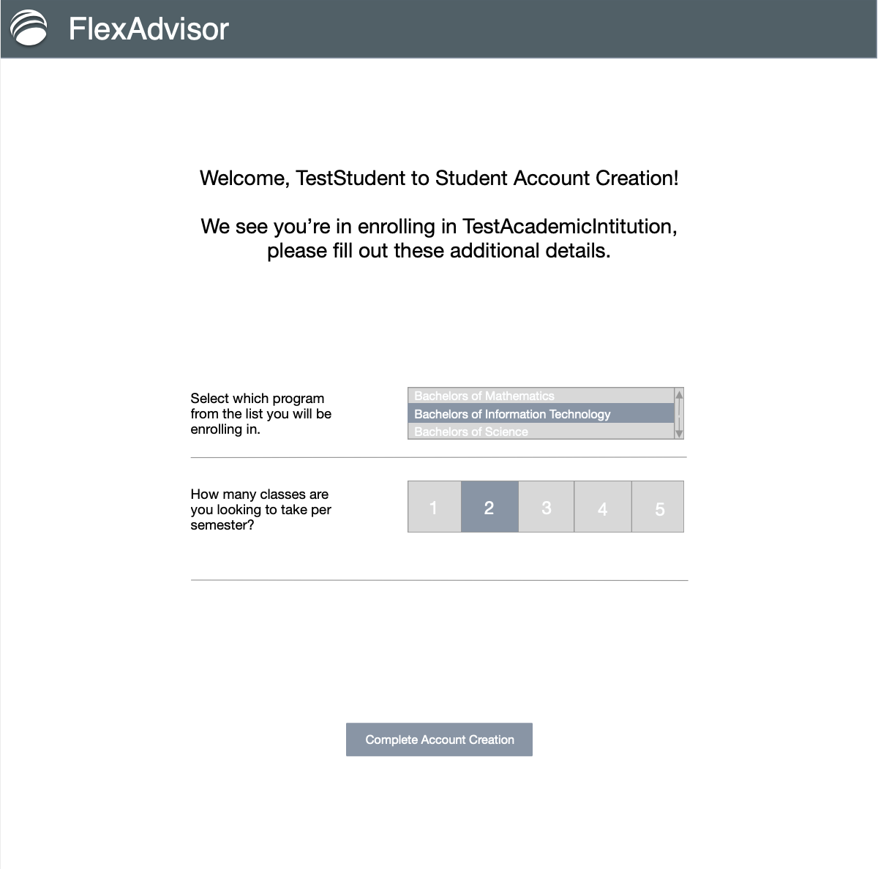

Instituion Registration Screen:
These fields are to be filled out by the system administrator of a school. An email will be sent to the FlexAdvisor team with all the details. If the school if verified and validated, a System admin profile will be created and an accompanying Academic ID will be sent for that school’s students.

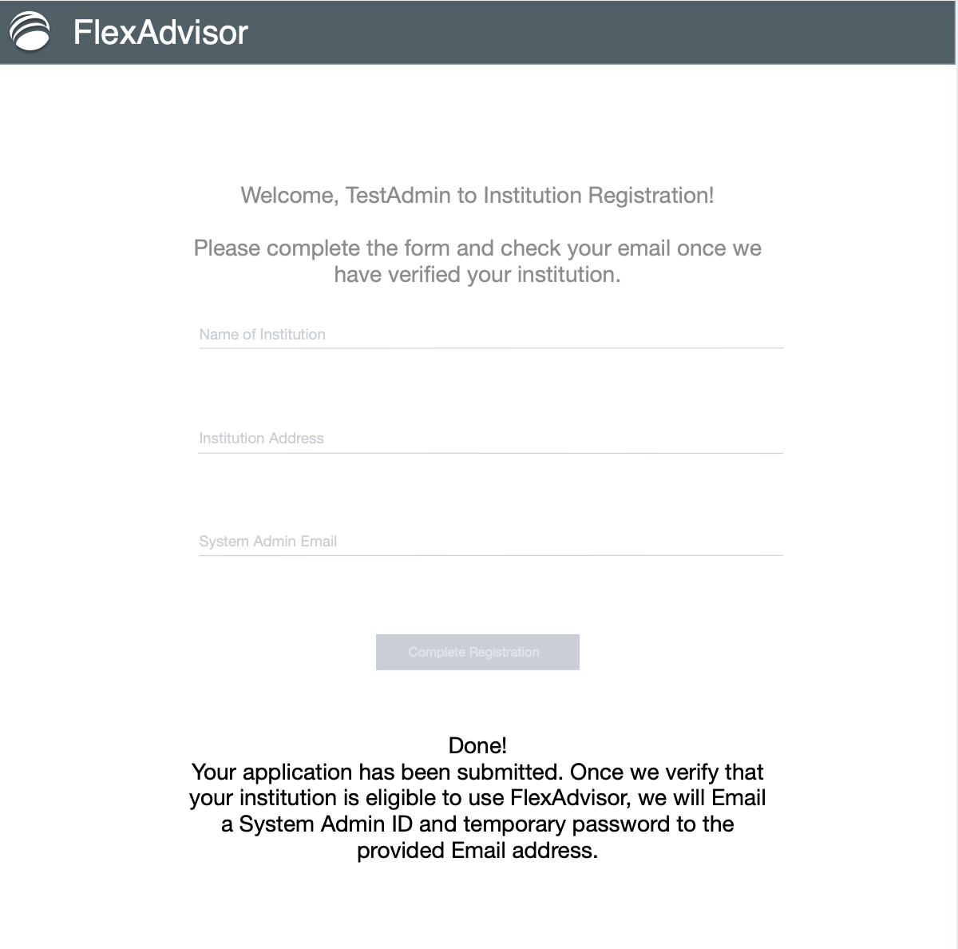

System Administrition Dashboard:
The Admin Dashboard will display the current director count for that school, advisor count, and the ratio of student assigned per advisor, as well as a log of daily log ins.
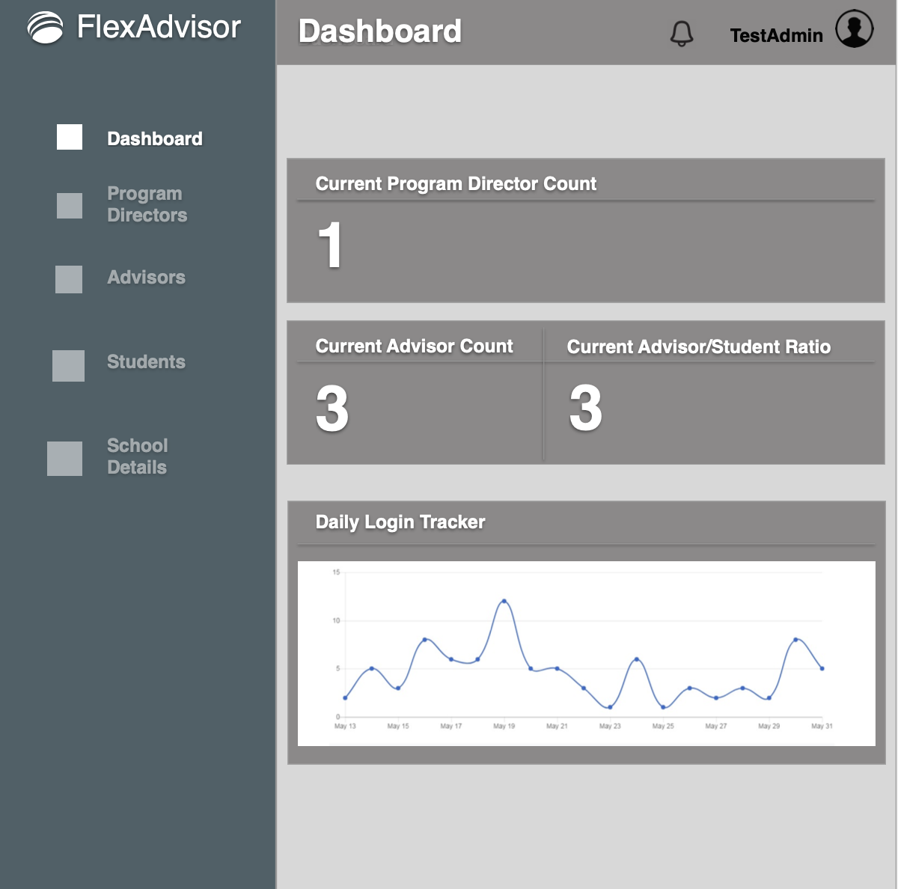

System Administrition – Program Director Overview:
Program Director Overview gives a chart of all the program directors for the school, as well and the number of advisors assigned to them. There is also an option to create program directors. This page also allows the system admin to select and delete a program director, but there in currently no edit feature.
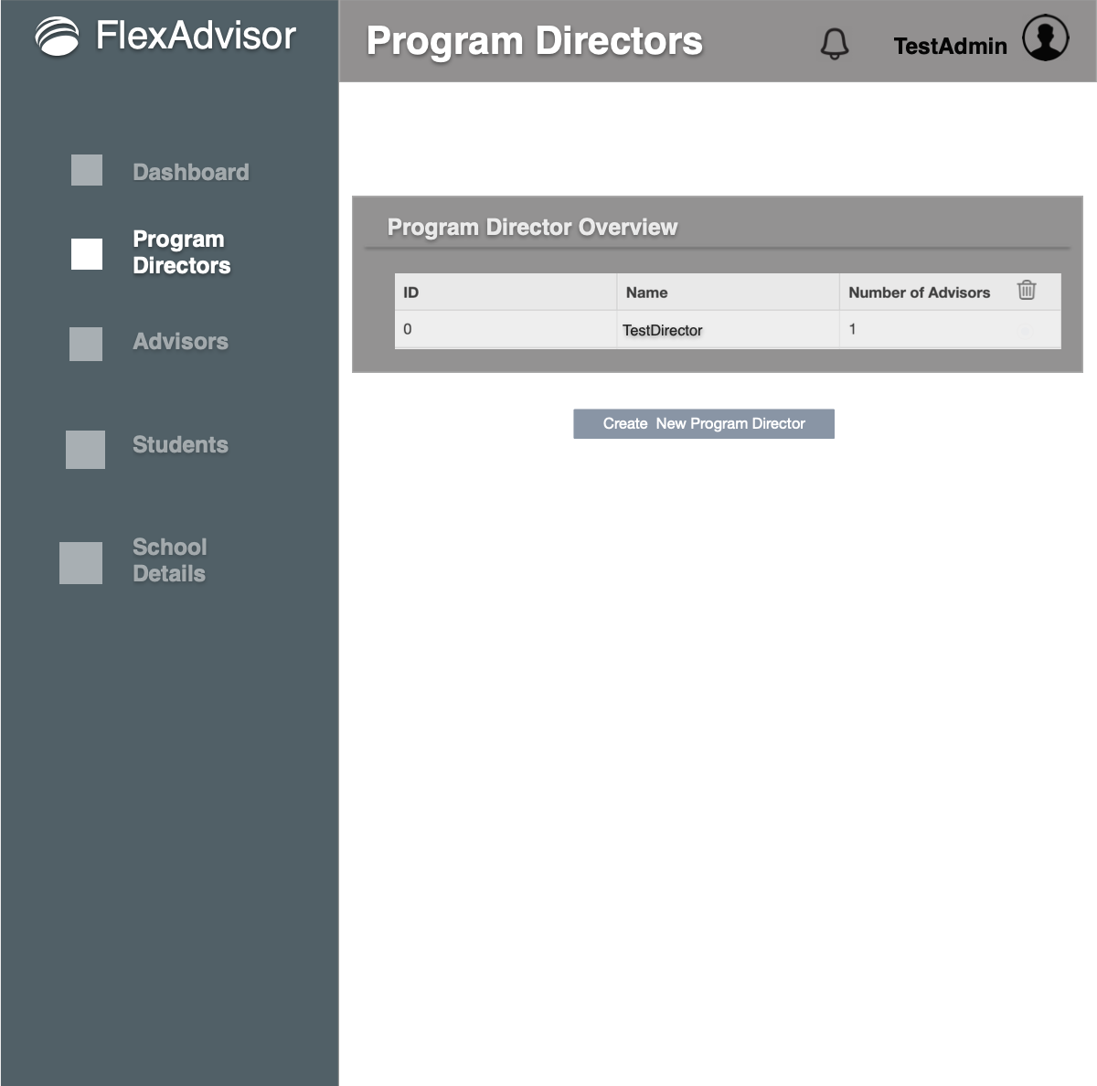

System Administrition – Program Director(create user):
Program Director creation page allows program directors to be added to the institution.
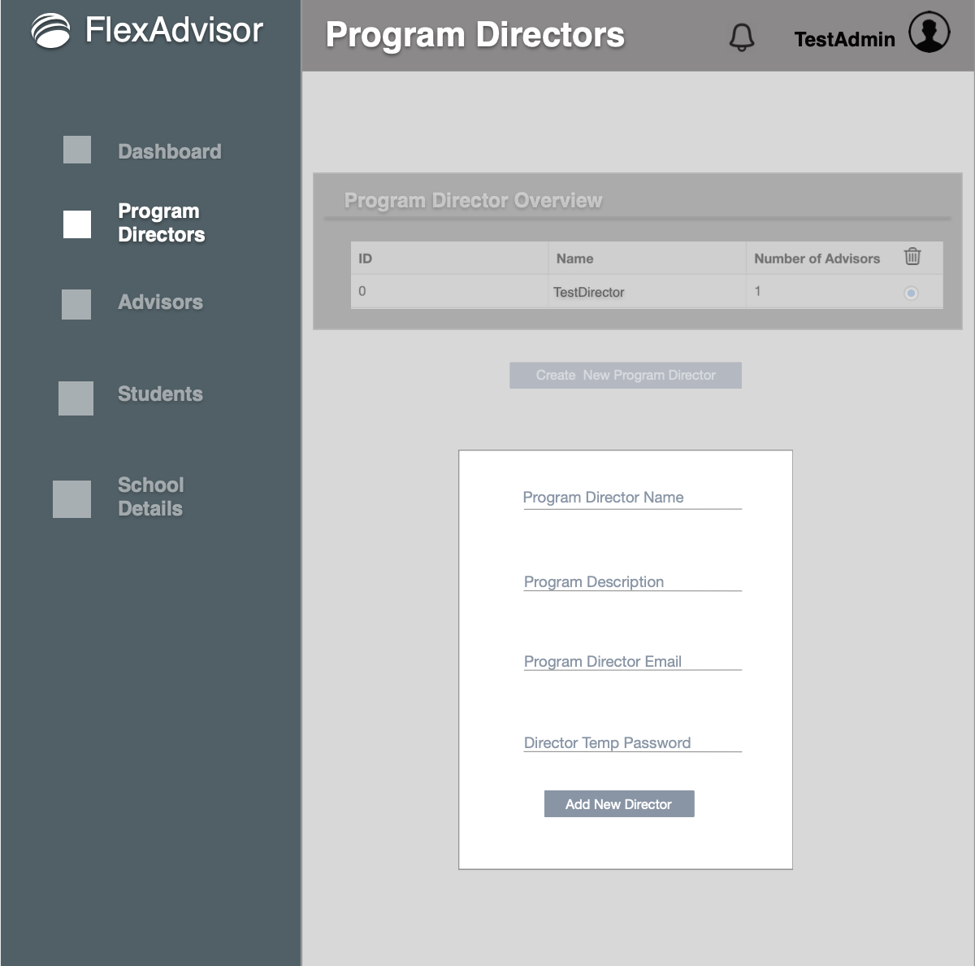

System Administrition – Advisor Director (Overview):
Advisor Overview gives a chart of all the program directors for the school, as well and the number of students assigned to them. There is also an option to create advisors directors. This page also allows the system admin to select and delete a advisors, but there in currently no edit feature.
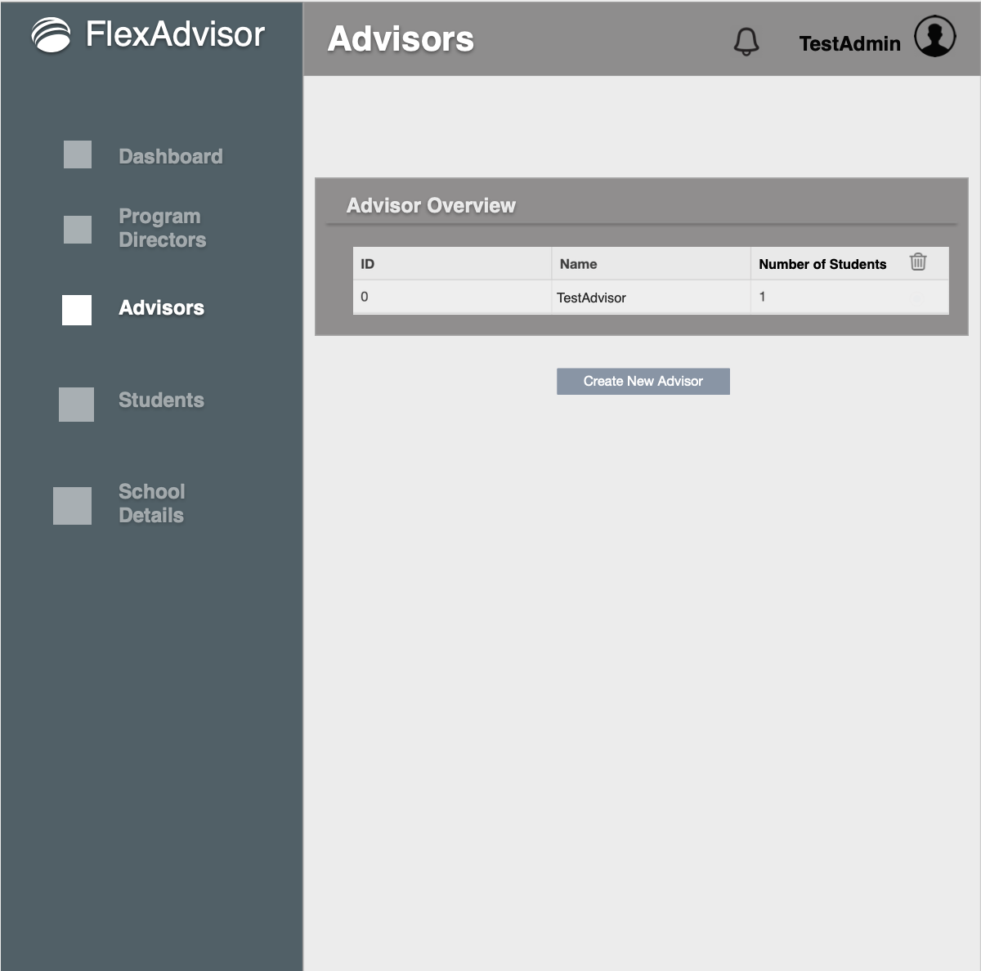

System Administrition – Advisor Director (user creation):
Advisor creation page allows advisors to be added to the institution under their according program director.
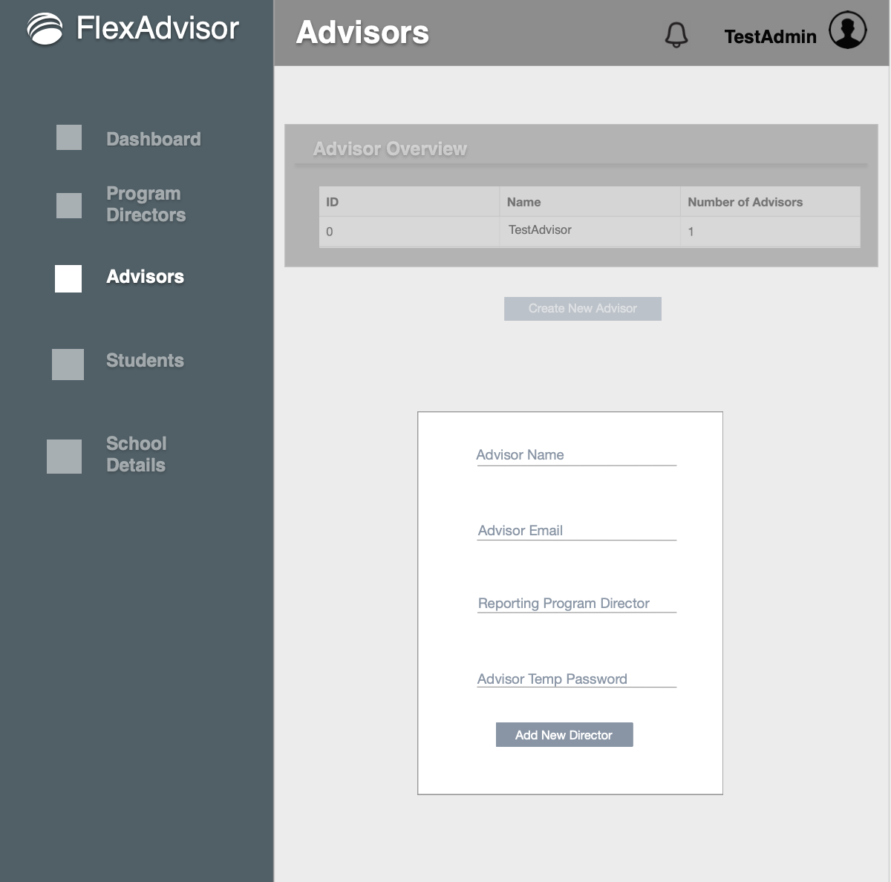

System Administrition – Student Overview
Student Overview gives a chart of all the students for the school, as well the advisors assigned to them. As of now, the System admin cannot create students, but he can remove them from the system.
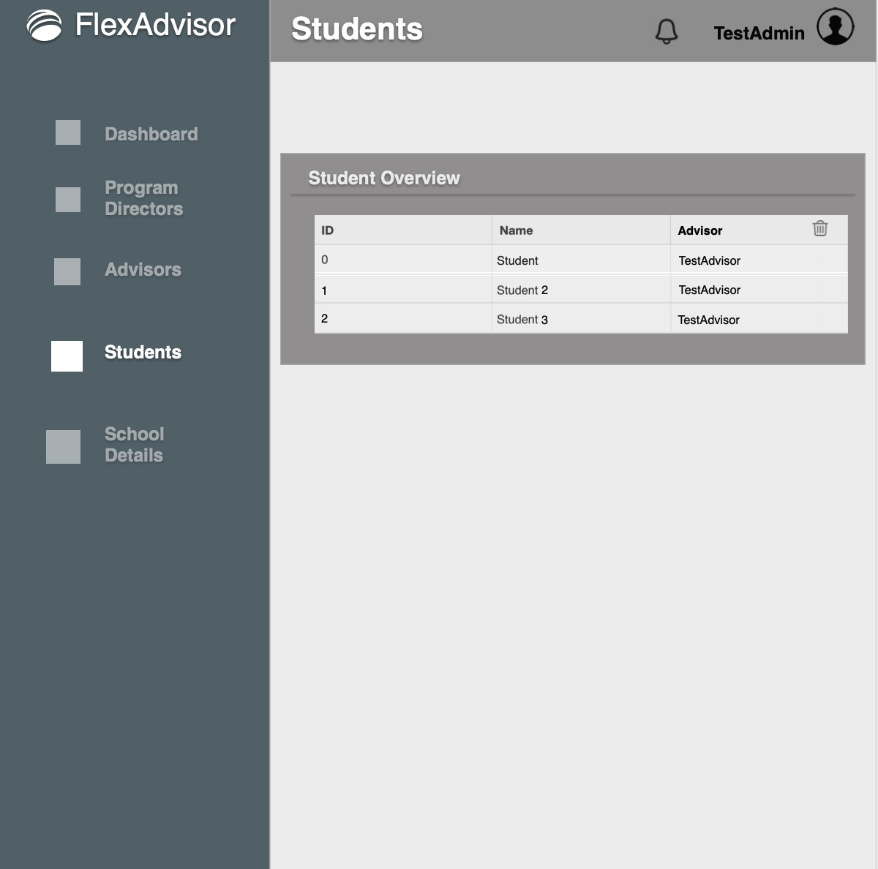

System Admin – School Details
School details allows the system admin to view the important institution details.
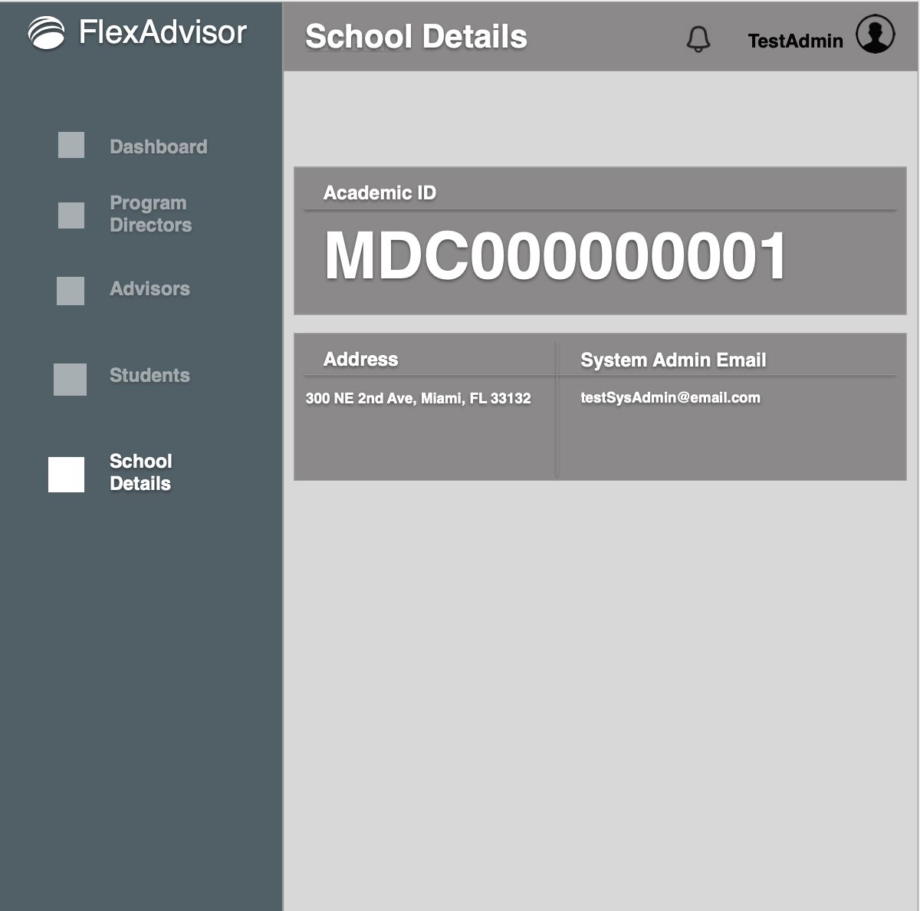

Program Director – Dashboard
Once a program director logs in, they will see their respective dashboard, which will show:
1) The Program Title in which the System Admin created their account for
2) It will display the current advisors reporting under their programs (circumstanced by department)
3) The current student to advisor ratio (circumstanced by department)
4) A Daily log in tracker to view how many people under their department have logged in.
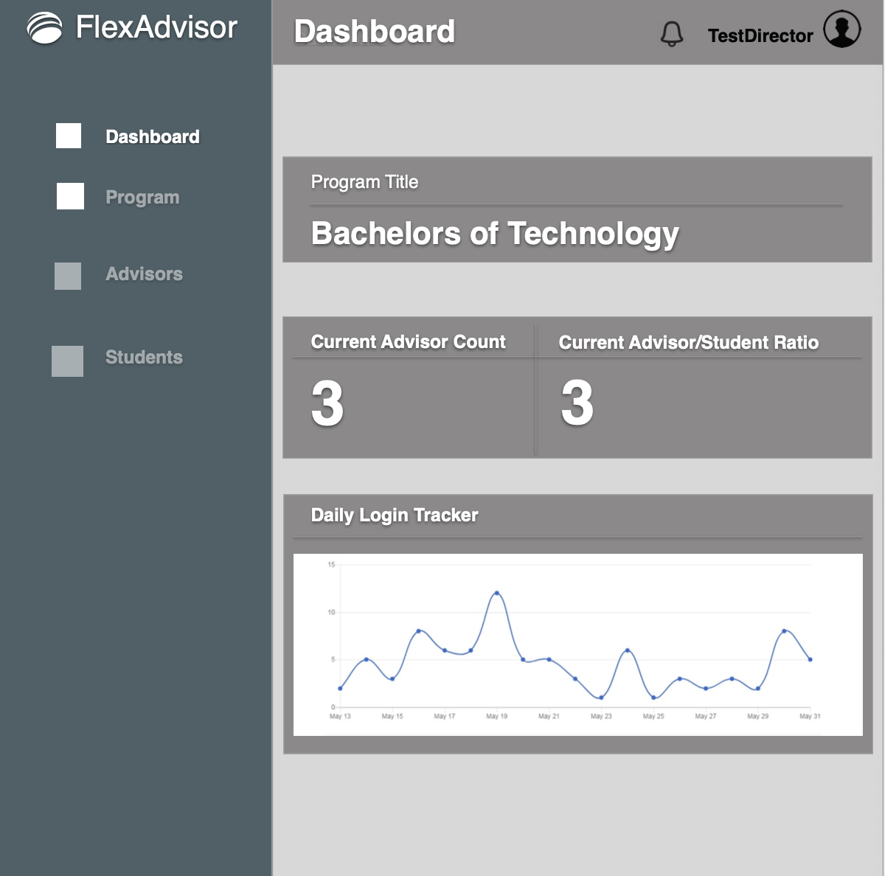

Program Director – Program
Within the Program Tab:
1) A program director can define the order in which classes should be taken to graduate.
This will populate the table which is referred to when a student is referencing which program, they are enrolling under upon account creation.
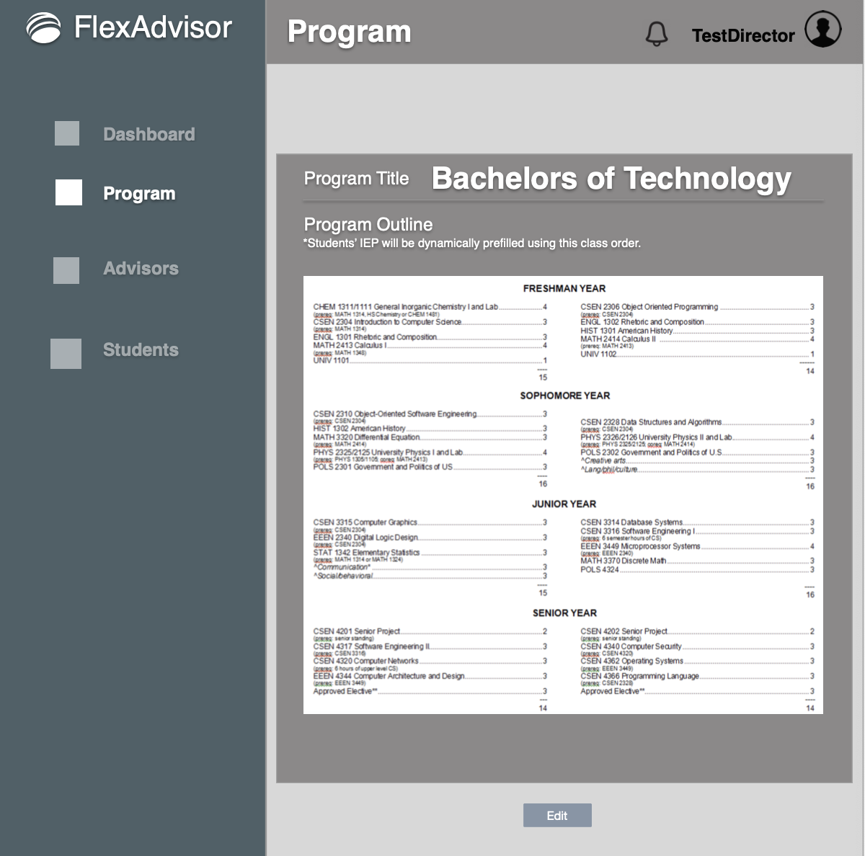

Program Director – Advisor Overview
Within the Advisor Tab:
1) Program director can create advisors which will be reporting under him. He can only create advisors under his account
2) Program directors can also delete advisor accounts. (similar to system admin but tied to the director directly creating account)
3) The Advisor profile created will have a username and temp password emailed to the director email used to create it
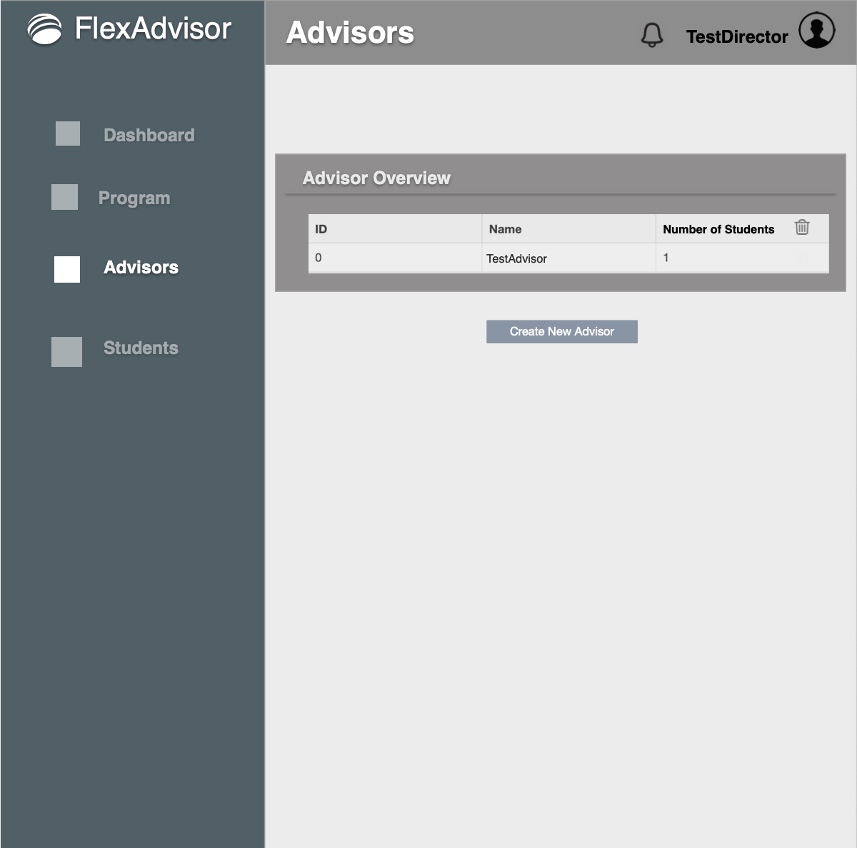

Program Director – Students Overview
Within the Student Tab:
1) Program director can view students which are enrolled under their program.
2) In future releases they will be able to click on the student to view their IEP and current schedule.
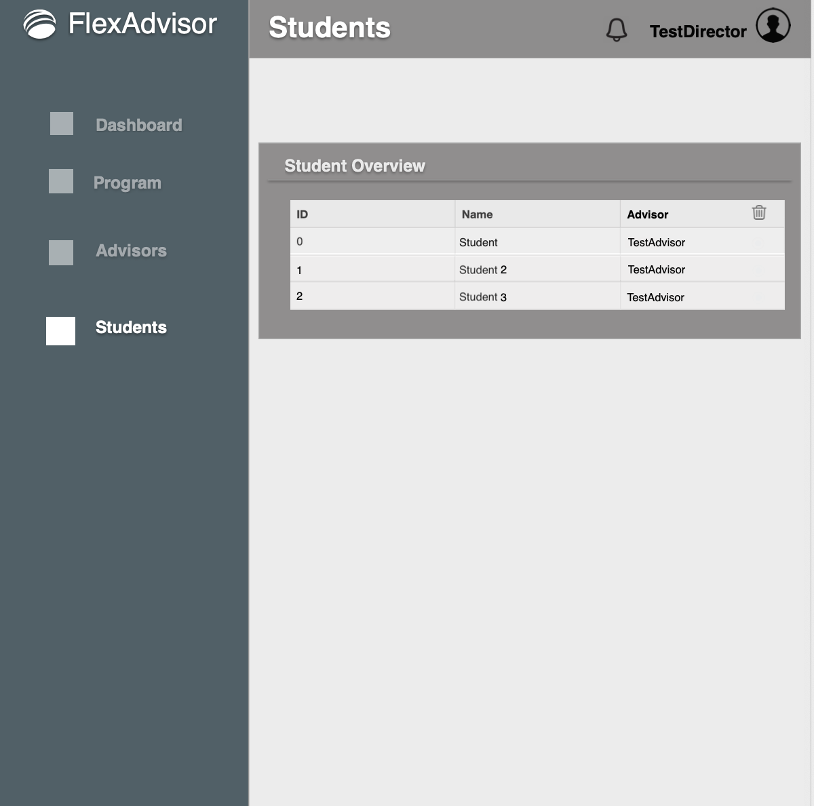

Advisor – Dashboard
Once an advisor director logs in, they will see their respective dashboard, which will show:
1) The Program under which they are advising (next release will include multiple assignment)
2) It will display the program director to which they report (next release will include multiple assignment)
3) The current number of students assigned to them
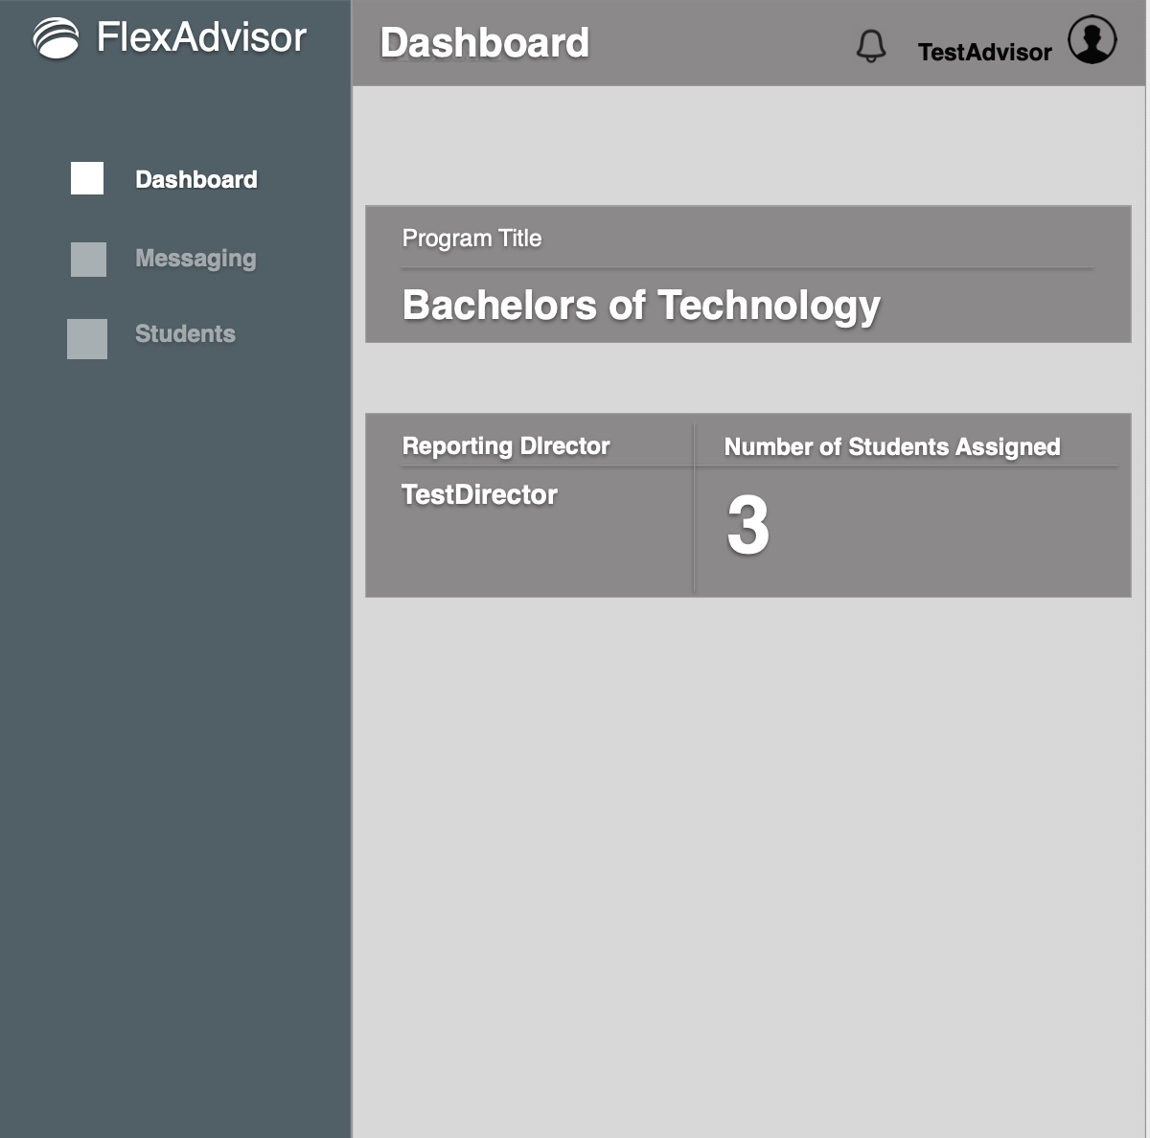

Advisor – Messaging
The messaging feature will notify of any current messages or pending tasks an advisor can act upon regarding the students that have been assigned to them. From this page an Advisor can:
1) Approve/Edit/Deny the dynamically created IEP upon student account creation
2) Approve/Edit/Deny any IEP change request
3) Message any of their assigned students or send them a new IEP to acknowledge
4) Future releases would allow for the schedule to be dynamically created based off the IEP
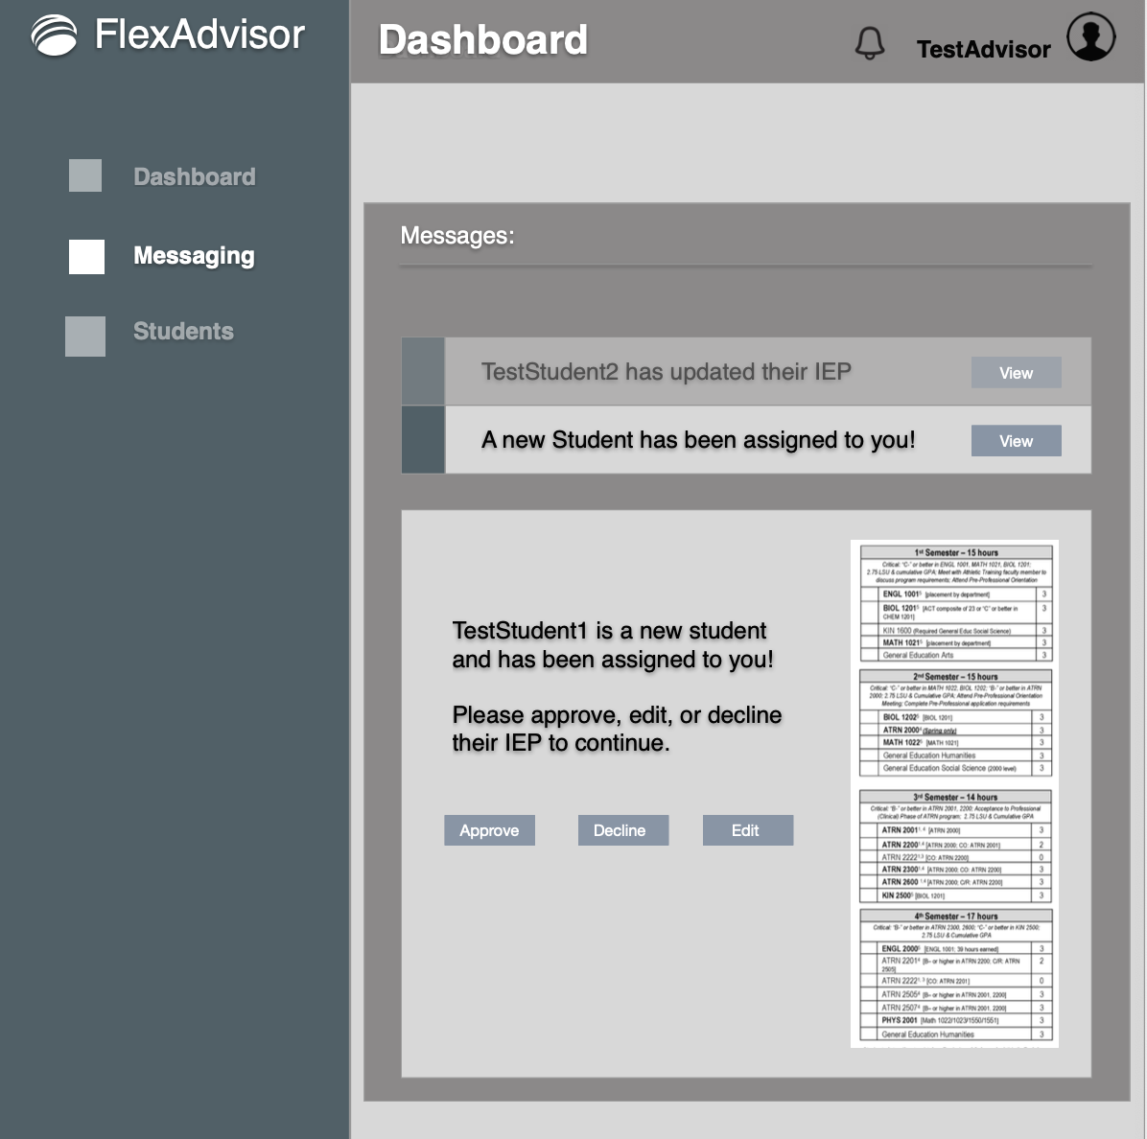

Advisor – Student Overview
Through the student overview page, an advisor can view all students that are assigned to them, as well as IEP status. Future releases will also allow for the advisor to edit and view the semester schedule from this page.
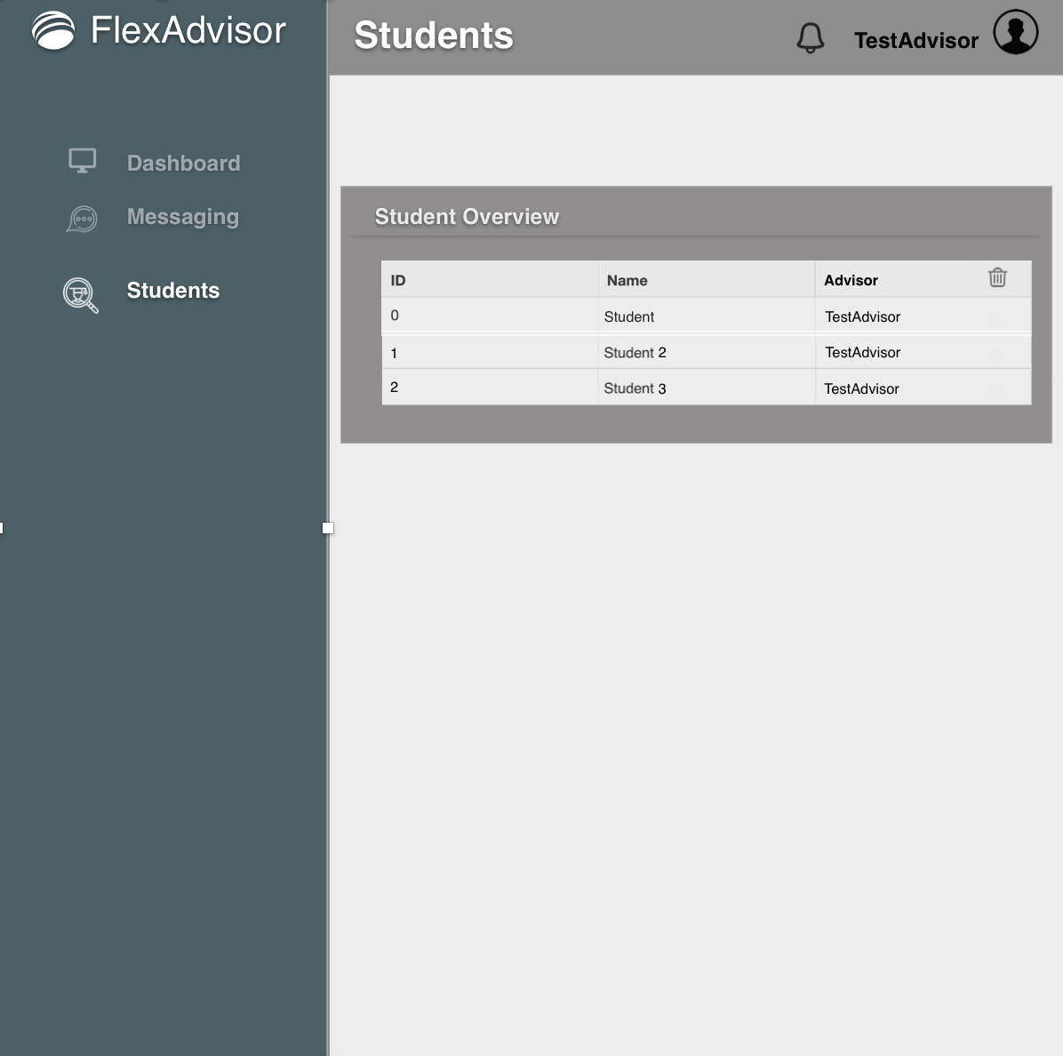

Student – Dashboard
Once a student logs in, they will see their respective dashboard, which will show:
1) The status of their IEP (Pending Approval/Approved/Declined)
2) The Program under which they are enrolled in
3) The advisor which has been assigned to them (click on either the advisor or IEP will take them to the messaging or IEP page respectively)
4) Schedule support will be added in further releases.
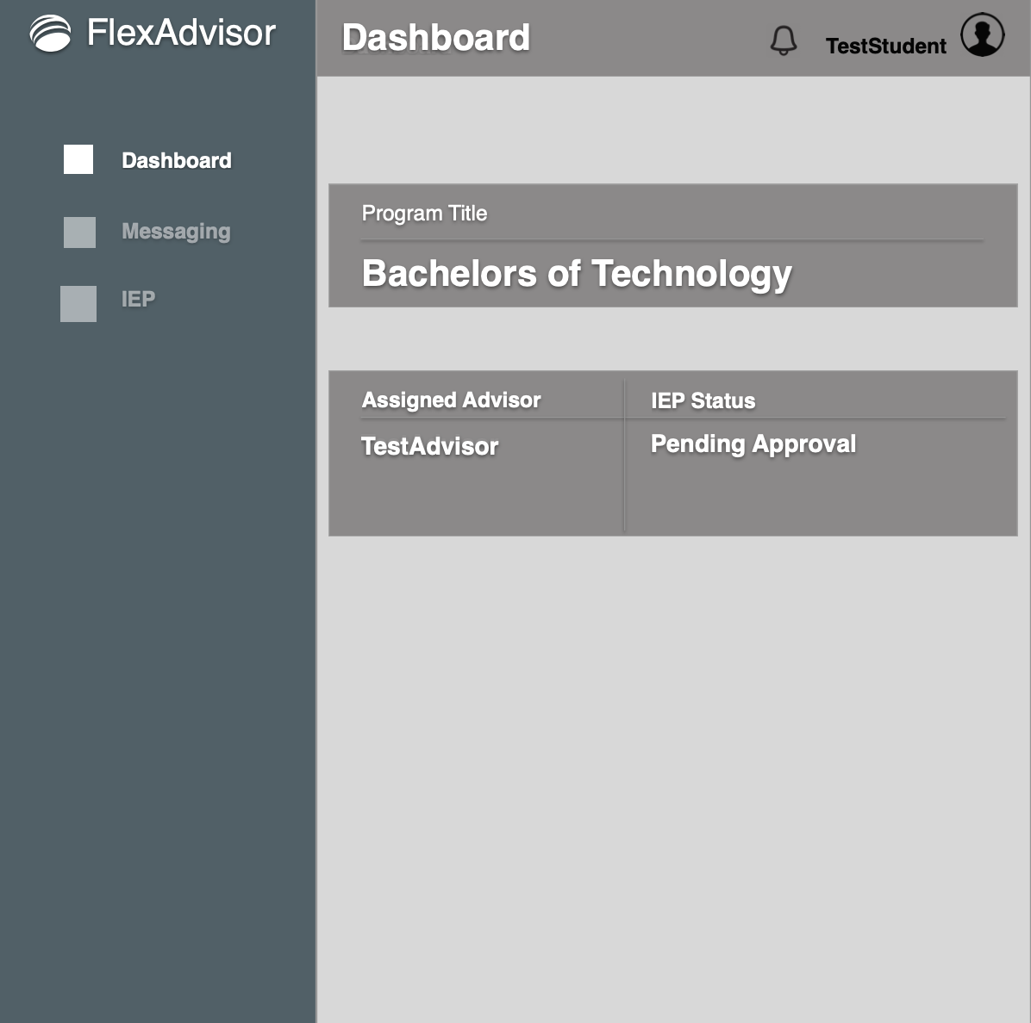

Student – Messaging
On the messaging tab, a student can see the on-going message thread with their advisor. A notification will be provided for any new messages.
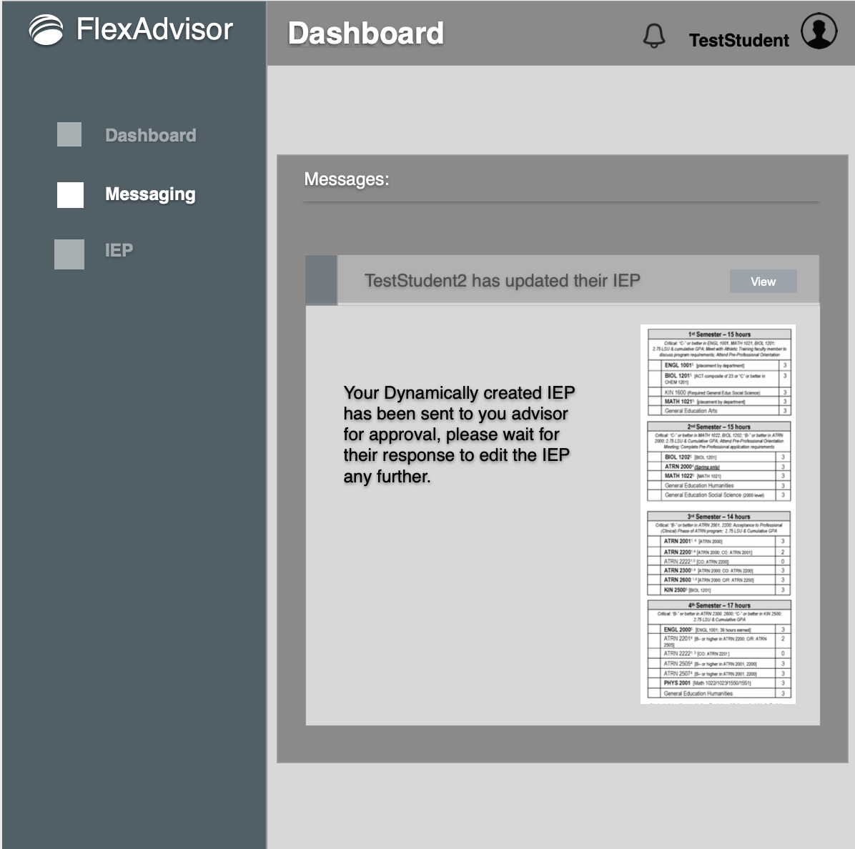

Student – IPE
Once the IEP is approved, it will be shown on this screen. Student options to “edit”, and “send to the advisor for approval” will also be shown on this screen after a valid IEP has been created. 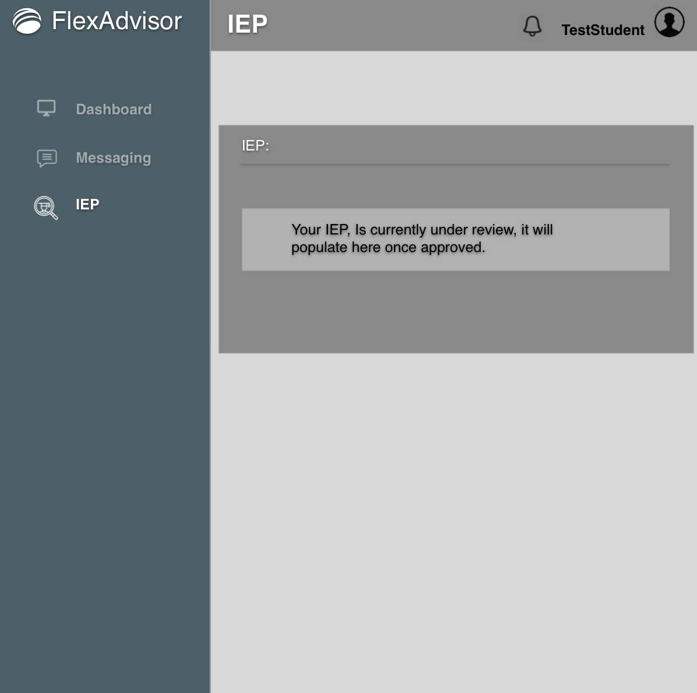

Hardware Interfaces
The application uses the keyboard, mouse and the monitor to display the program.

Software Interfaces
Not applicable for the first release of the product. In future releases, we are looking forward to connect to the existing schedule database and the existing payments system to serve as a single stop portal for all the interfacing software system that an academic institution might be using.

System Features/Modules

Login Screen
4.1.1 Description and Priority
When the web application is accessed the log in page will always greet the user
4.1.2 Stimulus/Response Sequences
Once the web application is accessed the login screen will greet the user. Two tabs will be available
4.1.3 Functional Requirements
REQ-1: Login will allow existing users to enter their FlexAdvisor account
REQ-2: ”Forgot Password’ module is called from this module
REQ-3: A tab for “New User” will call the new user module

Forgot Password
If a user selects “Forgot Password” from the login screen, this module is shown
4.2.1 Description and Priority
Once the user selects this option the right-hand component is refresh with the forgot password module.
4.2.2 Stimulus/Response Sequences
From the login page, user selects the “forgot password link”
4.2.3 Function al Requirements
REQ-1: A User can input their password; this will trigger an activity to check if the email is registered in our database.
REQ-2: If the email exists in the database, a link is provided to create a new password (this is a single use link).
REQ-3: The “Go Back” link on the forgot password page takes the user back to the initial login screen.
REQ-6: Once the email is sent, provide the user with a confirmation.

New User
The new user component will be called once the “new user” tab is selected from the “Login” module.

4.3.1 Description and Priority
Once the user selects the “new user” tab, the page will load using the new user component
4.3.2 Stimulus/Response Sequences
User clicks new user from the login page
4.3.3 Functional Requirements
REQ-1: Once a field is entered, it should be validated
REQ-2: When “create your account” is selected, it is verified that the email is not already registered for flex advisor.
REQ-3: The account is created if no existing profile exist.
REQ-4: The “Register your academic Institution” module is called at the bottom of this component

Register Your Academic Institution
If an institution is completely new to FlexAdvisor, this would be the initial point of entry for an institution’s system admin to start the application process.
4.4.1 Description and Priority
An institution’s system admin would click the button from the “create new” module to launch the additional page for institution registration.
4.4.2 Stimulus/Response Sequences
User will clock on the register your institution button and the page will refresh with the registration page.
4.4.3 Functional Requirements
REQ-1: The inputs will be validated upon text being entered.
REQ-2: When user clicks “Complete Registration” an email will be sent to the FlexAdvisor team.
REQ-3: Once the email is sent, a confirmation will be displayed, and the user will be redirected to the homepage.
REQ-4: If the FlexAdvisor team approves they will create a system admin user for the school

Dashboard
Displays important information for the user after logging in

4.6.1 Description and Priority
Once a user logs in, they will be taken to their dashboard, where some simple elements can be seen
4.6.2 Stimulus/Response Sequences
User logs into the web application. Depending on the user permission and details, they will see a customized profile.

4.6.3 Functional Requirements
REQ-1: The Dashboard will display information according got who is logged in
REQ-2: For Admins: Director Count, Advisor Count, Advisor/Student Ratio, and a Daily log in tracker chart
REQ-3: For Director: Their respective program title, Advisor Count(under program, and the student ratio); as well as the daily log in track circumstanced to their program.
REQ-4: For Advisors: The program for which they are advising, their reporting director, and number of students assigned to them.
REQ-5: Data will be loaded dynamically from the database

User List
User lists will be used to show a certain collection of users directly from the database. Depending on the user that is logged’ permission level, they will have access to view/edit different user lists and access specific credentials tied to that user.

4.7.1 Description and Priority
A System Admin, Director, or Advisor logs in and wants to the list of users which report to them and access specific information, a user list would allow for this.
4.7.2 Stimulus/Response Sequences
The Option to access a specific user list would be present on the sidebar for a user once they are logged in. This will call the “create user” function (same used for students, but with specific parameters to allows a different permission set)

4.7.3 Functional Requirements
REQ-1:
System Admins rights:
Program Director: Read/Write
Advisors: Read/Write
Students: Read
Program Director right(specific to their program)
Advisor: Read/Write
Students: Read
Advisor rights:
Student: Read/Write(with Director approval)
REQ-2: The “create user” function is called with the specific parameters that are entered by a user if they select to add a new user
REQ-3: Editable lists can delete user.
REQ-4: Making the list clickable to expand user details will follow in upcoming releases.

Create User
The create user function is the main data accessing function that is used to validate and insert users into the data collection

4.8.1 Description and Priority
Once the user input is validated to not be null and the create user option is selected, this component will run
4.8.2 Stimulus/Response Sequences
User selects to create a user, the component will run, and display a confirmation screen if user creation was completed.
4.8.3 Functional Requirements
REQ-1: Allow different permission levels to be granted depending on who is creating the account.
REQ-2: Checks the exiting data collection cloud for existing entries with the same email for the same institution. Returns a “User already exist” message if found.
REQ-3: Will insert a user into the data collection and send a confirmation notification with a temp password for internal faculty created accounts.
REQ-4: An email sent will be sent verifying the account creation once it has been inserted into the FlexAdvisor data collectoin.
REQ-4: For students, an additional preference module is called – “Create IEP”

Paragraph option Menu/Alignment
Paragraph Options Menu is at the top of the GUI with the following four sub-options: Alignment, or Bullets.
4.9.1 Description and Priority
Once the user selects an option in the main screen, select the “Alignment” module in a sub option of the Paragraph options menu. There will be three options for alignment: left aligned, center aligned, and right aligned. By default, the text will be left aligned.
4.9.2 Stimulus/Response Sequences
User starts the program. Then, any time, with the initial screen displayed, the user clicks in paragraph options menu and select Alignment.
4.9.3 Functional Requirements

REQ-1: The Paragraph Options Menu must be displayed, and the user clicks on Alignment.
REQ-2: When the user clicks on Alignment, select one of the three options displayed by clicking on one of them.
REQ-3: When the user clicks left aligned option, the selected text and all new typed text will be aligned to the left.
REQ-4: When the user clicks center aligned option, the selected text and all new typed text will be aligned to the center.
REQ-5: When the user clicks right aligned option, the selected text and all new typed text will be aligned to the right.
REQ-6: If there is no text highlighted, the line in which the cursor is, will change according to the option selected.
REQ-6: It is necessary the user select Paragraph options to select Alignment.
REQ-7: When the user clicks another location on the GUI other than Alignment or other of the Paragraph options, the Paragraph Option Menu will close.

School Details
Visible only to the system admin, displays core information for his institution.
4.10.1 Description and Priority
Displays critical information for his institutions
4.10.2 Stimulus/Response Sequences
System Admin logs in, clicks on “School Details” from the sidebar.
4.10.3 Functional Requirements

REQ-1: Must display the Academic ID, Address, and system admin email.
REQ-2: These fields will be editable in the future Bullets or other of the Paragraph options, the Paragraph Option Menu will close.

Program list
Visible only to owning program director, an editable list which will store the classes to graduate from the program.
4.10.1 Description and Priority
Stores the class list as an array within the data collection
4.10.2 Stimulus/Response Sequences
Program Director selects “Program” from the sidebar.
4.10.3 Functional Requirements

REQ-1: Must allow up to 80 classes
REQ-2: Allows for substitution entries in a subsection. (transfers credits/test credits etc.)
REQ-3: There is only 1 program list per program director, and it is directly tied to the student IP creation.

Create IEP
Background process called after account creation specific only to students
4.10.1 Description and Priority
Additional screen to gather details from student upon account creation to create their IEP
4.10.2 Stimulus/Response Sequences
Student user account is created, but initial log in has not been completed.
4.10.3 Functional Requirements

REQ-1: Must display the current programs available for their institution
REQ-2: Will ask the student how many classes they are planning on taking per semester
REQ-3: Calls the “Assign Advisor” method to load balance and assign an advisor to the newly created student
REQ-3: Will access the program list for that specific program and divided the classes per semester.- this will be stored as the IEP[] item in the student user collection. IEP Approved true/false value will be set to false, and a notification will be sent to the advisor to check for approval.

Messaging
Restricted to student/assigned advisor
4.10.1 Description and Priority
Messaging thread used to maintain approval settings of the IEP and pass auditable notes
4.10.2 Stimulus/Response Sequences
Used primarily by Advisor through sidebar notifications and the student to send IEP changes for approval.
4.10.3 Functional Requirements

REQ-1: Must allow the student to message their assigned advisor

View IEP
Restricted to student access and through the advisor student list click-through
4.10.1 Description and Priority
Displays an approved IEP
4.10.2 Stimulus/Response Sequences
A student or advisor click on the view IEP option, and the IEP specific to that student is dynamically populated.
4.10.3 Functional Requirements

REQ-1: Must allow the student to message their assigned advisor
REQ-2: Dynamically updates the IEP status based on the advisor input.

Requirements

Performance Requirements
Heroku, and MongoDB are both higher scalable platforms that can meet most performance and availability needs. All processing will be handled through the cloud servers, any modern web browser can access and use this web application.
Estimated pricing for 10 campus (upper limit of 10k users per campus) support:
Backend: MongoDB (Hosted through AWS):1$ per hour
Frontend/Middleware: React/Node.js (Hosted through Heroku) 50$ a month

Safety Requirements
Both cloud servers will handle safety requirements.

Security Requirements
Password hashing will be used

Software Quality Attributes

Maintainability
- The system must be written using the React js framework, Node.js and Express as middleware and MongoDB as the Backend.
- Since the system will be fully open stack (MERN), it will be highly maintainable, scalable, and easily migrated into any environment
- The application will be following the micro-services approach, which creates robust small, maintainable, and highly testable API’s with predictable results from a uniform data collection.

Availability and Reliability
- Heroku and AWS both promise over 99% availability through their cloud platforms.

Scalability Requirements

- A completely cost-free approach can be done at a local scale before launching to a full multi campus approach.

Appendix A: Glossary
- A Software requirements specification (SRS), a requirements specification for a software system, is a complete description of the behavior of a system to be developed and may include a set of use cases that describe interactions the users will have with the software.
Source: http://en.wikipedia.org/wiki/Software_requirements_specification

